**Blast Assignment**

**Introduction to Bioinformatics**

**BTX-431**

**Submitted To : Submitted By :**

**Dr. Sumer Singh Meena Ankit Goyal**

**Assistant Professor Roll No. : 17103011**

**BioTech Department Branch : CSE Final year**

1. Banyan Tree (Ficus benghalensis) :

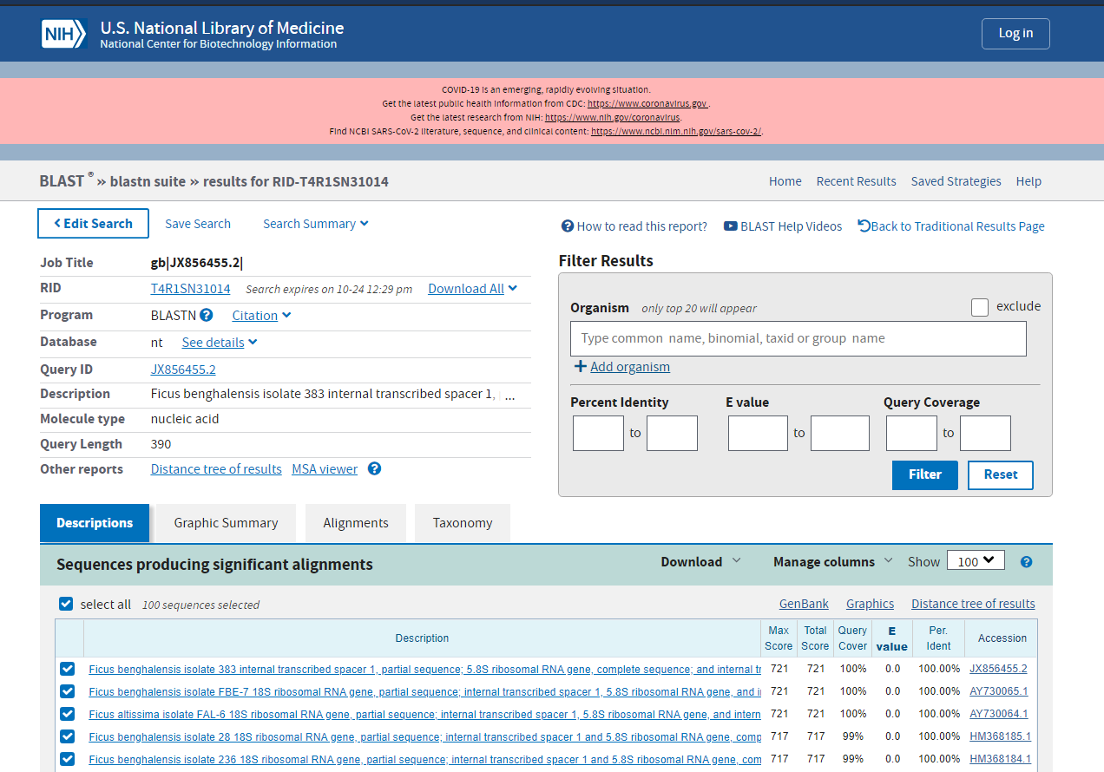

1. Peacock (Pavo cristatus):

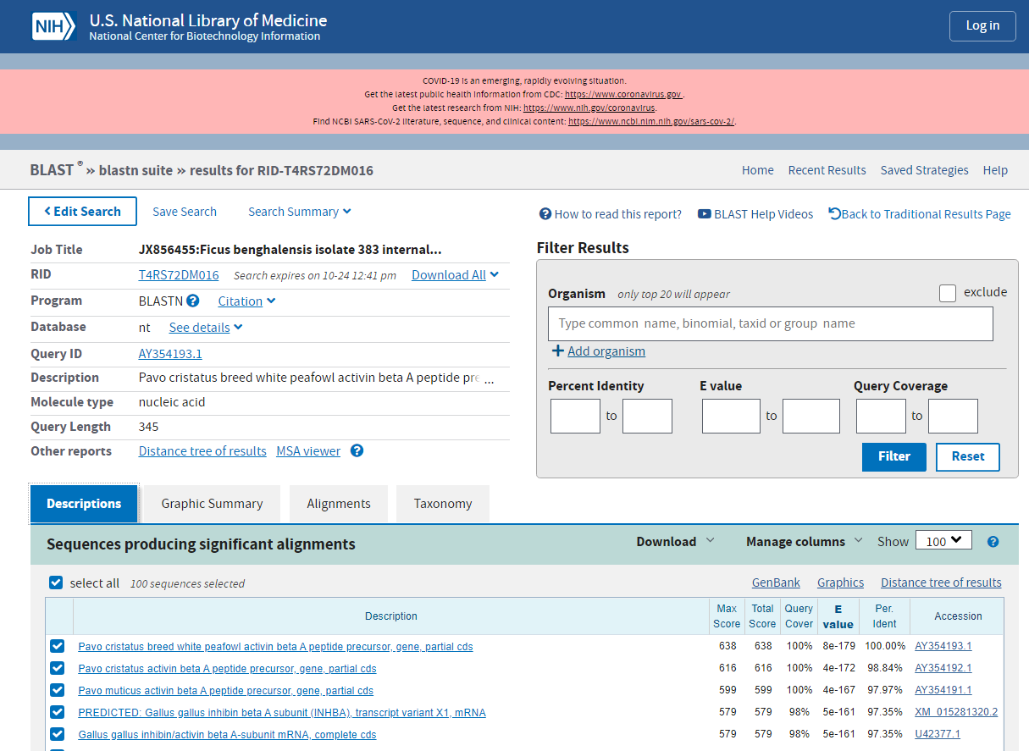

1. Penicillium:

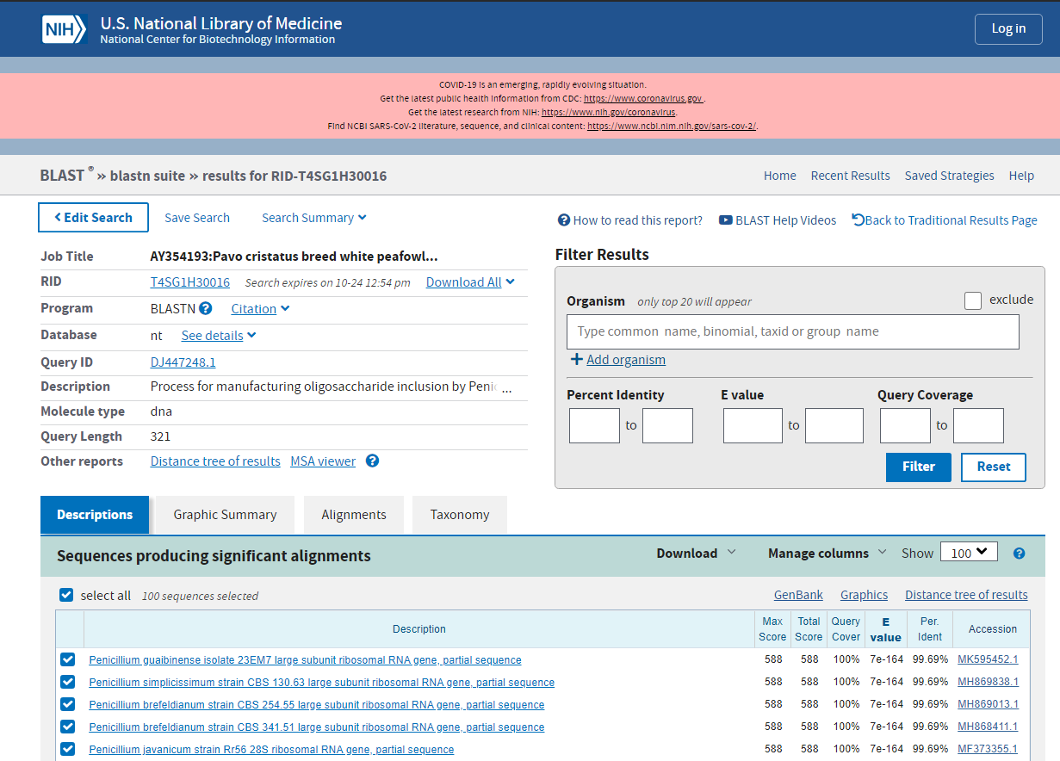

1. Lactobacillus acidophilus**:**

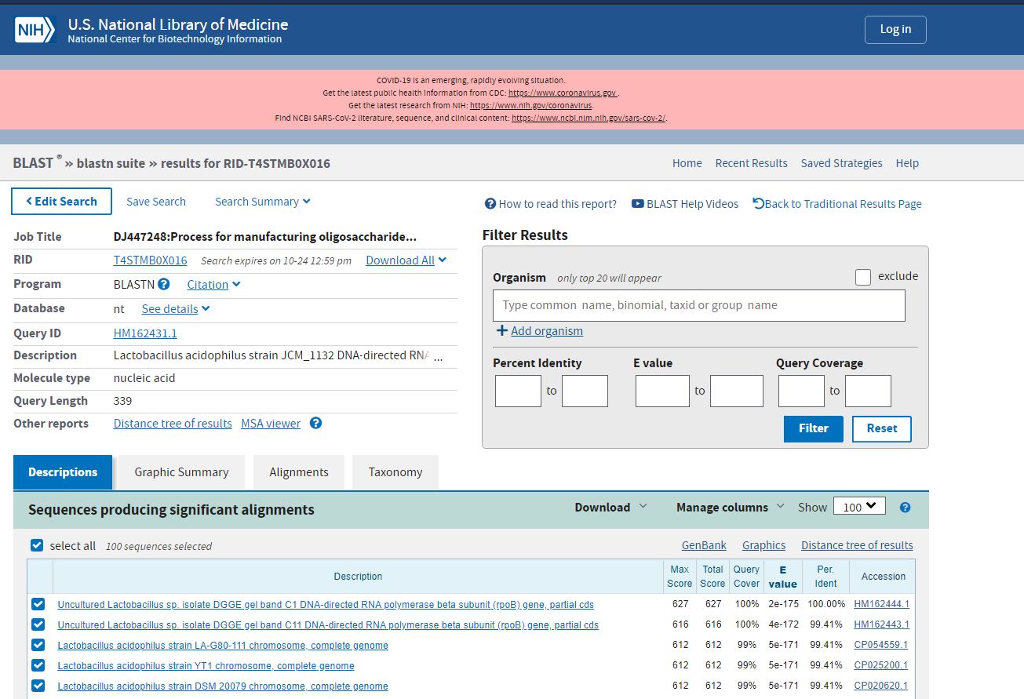

1. HIV(human immunodeficiency virus):

